Project Title: Detection and Classification of Retinal Disease using Convolution Neural Network with Transfer Learning
Student Names: Aditya Agarwal (RA2111004010177)
Abhinav Panwar (RA2111004010210)
Rohan Gupta (RA211043010033)
Project Guide : Dr. S. Latha, Associate Professor /ECE, SRMIST-KTR
ABSTRACT:
Eye diseases, particularly Age-related Macular Degeneration (AMD), continue to pose a significant threat to vision health worldwide, with early detection being crucial for effective treatment and prevention of irreversible vision loss. Traditionally, the diagnosis and categorization of retinal conditions have relied on manual analysis of Optical Coherence Tomography (OCT) images, a process that is not only time-consuming but also demands highly specialized medical expertise. With the advent of artificial intelligence and deep learning, automated approaches have emerged as powerful tools in the field of medical imaging. This project introduces a robust deep learning framework for the automated classification of OCT images, leveraging both a custom Convolutional Neural Network (CNN) and prominent transfer learning models, including MobileNet, ResNet50, GoogleNet, and DenseNet. The models are trained using various hyperparameter configurations, such as learning rates, number of epochs, and optimization algorithms, to achieve optimal performance. A comprehensive evaluation of the models is carried out using performance metrics like accuracy, precision, recall, F1-score, and confusion matrices, enabling a thorough comparison of their classification capabilities. This structured analysis allows us to determine the most accurate and efficient model for identifying retinal diseases from OCT scans. The findings of this research demonstrate the practical potential of deep learning in ophthalmology, offering a scalable and cost-effective solution that can be integrated into clinical workflows to aid in the early and reliable diagnosis of AMD and other retinal disorders. Furthermore, this project aligns with the objectives of Sustainable Development Goal 3: Good Health and Well-being, by harnessing cutting-edge technology to enhance healthcare delivery, improve patient outcomes, and promote proactive and preventive medical practices.

RESULTS:
The implemented deep learning models—MobileNet, ResNet50, GoogleNet, DenseNet, and a custom CNN—were trained on an OCT dataset for the classification of retinal images into AMD and normal categories. Each model underwent training under varied hyperparameter settings such as learning rate, epoch count, and optimization techniques to determine the best configuration for maximum performance.
Among all models, DenseNet emerged as the top-performing model, demonstrating the highest classification accuracy and balanced precision-recall performance. ResNet50 also performed well, with slightly lower accuracy but strong generalization capabilities. The custom CNN, while lightweight and faster to train, showed lower accuracy in comparison to the transfer learning models, indicating that pre-trained architectures are more suitable for medical imaging tasks involving complex feature extraction. Below Fig.1 is the image of the model comparison graph.
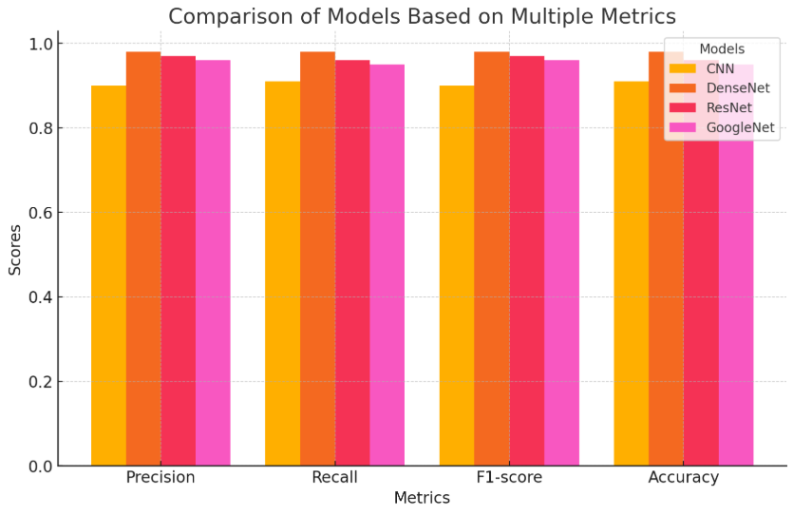

Fig.1 Model Comparison Graph
To measure the effectiveness of each model, several evaluation metrics were used:
- Accuracy: To evaluate overall correct predictions.
- Precision: To assess how many predicted AMD cases were actually AMD.
- Recall: To determine how many actual AMD cases were correctly identified.
- F1-Score: To find the balance between precision and recall.

In addition to the model development, a responsive and interactive website was created to complement the research. The primary purpose of the website was to offer a practical, user-friendly platform to showcase the functionality of the trained models. Users can upload OCT images and receive real-time classification results indicating whether the image corresponds to an AMD-affected or normal retina. A sample image has been demonstrated below in Fig 2 and 3. The website interface was built using React.js for the frontend, ensuring smooth user experience and responsiveness across devices.
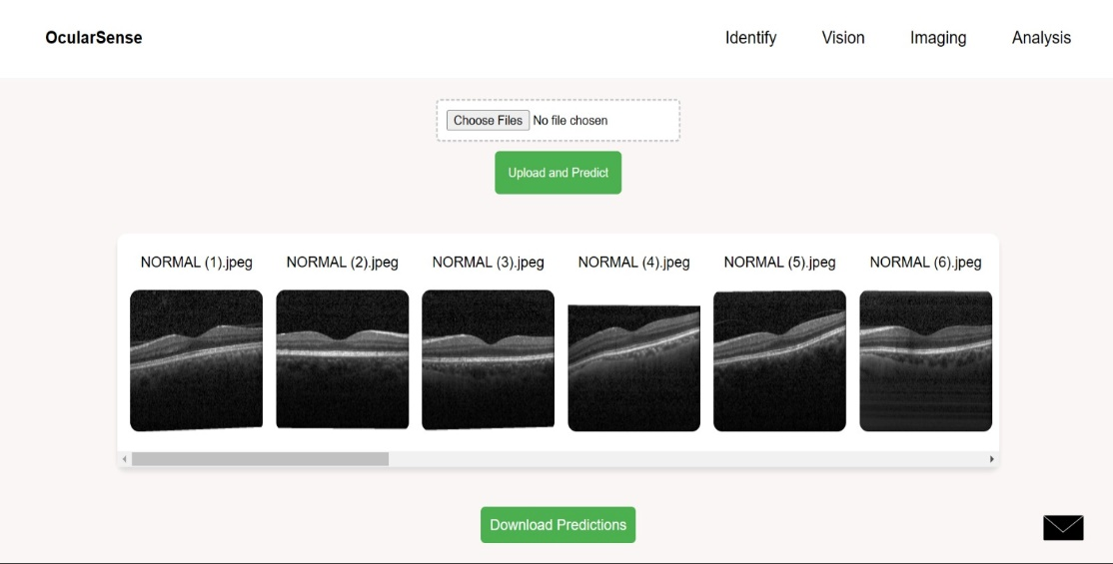

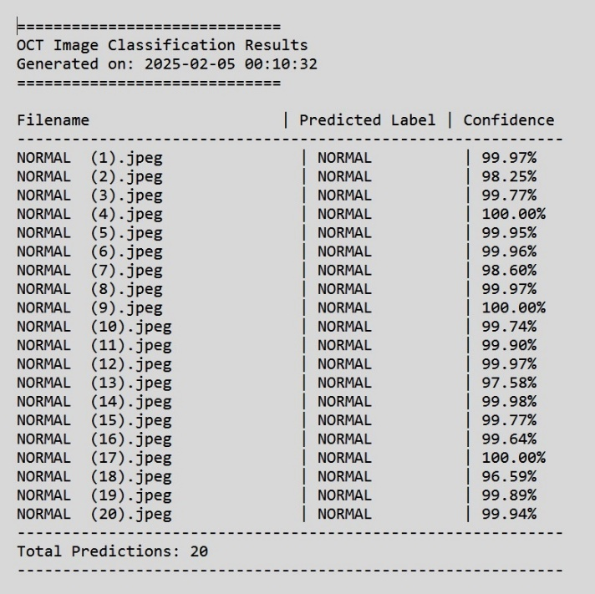
Fig.2 Website Desktop Version

Fig.3 Output Predictions

This platform serves not only as a demonstration tool for the project but also as a foundation for future expansion, where clinical partners or healthcare providers could integrate the system into their diagnostic workflow. By combining model interpretability and ease of access through the web interface, the project extends its real-world applicability.
Objectives | - To Automate the detection of retinal diseases like AMD using OCT image classification.  - To Identify the most accurate deep learning model through comparative analysis.  - Provide an interactive web platform for image upload and result visualization.
Knowledge acquired from the courses studied | - This project applied and reinforced concepts from various courses such as Deep Learning, Machine Learning, Digital Image Processing, Artificial Intelligence, and Web Development.  - The knowledge of neural networks, convolutional operations, overfitting control techniques, activation functions, and optimization algorithms gained through coursework played a vital role in developing and fine-tuning the deep learning models.  - Additionally, the web development component utilized skills from courses like Full Stack Development and UI/UX Design, including frontend development with React and backend integration.
Realistic Constraints | - Data Availability  Limited access to high-quality, labeled OCT datasets.  - Computational Resources  Training deep learning models required high GPU capacity, which was managed using cloud-based platforms and local systems.  - Time Constraints  Balancing academic schedules with model training and web development timelines.  - Scalability  Ensuring the solution can be extended to include more classes or real-time diagnosis without losing performance.
Standards to be referred/followed | - IEEE Std 11073-2019: Health informatic—device interoperability— Part 20701: Point-of-care medical device communication— OCT device specialization  - ASTM E2526-16: Standard guide for OCT imaging of the eye.
Multidisciplinary tasks involved | - Electronics and Communication Engineering  Understanding of imaging systems like OCT.  - Computer Science  Model development, algorithm implementation, data preprocessing, and backend logic.  - Healthcare/Ophthalmology  Understanding the significance of AMD detection and OCT imaging in clinical workflows.  - Design and User Experience  Creating a clean, responsive, and user-friendly interface for the website. This multidisciplinary approach enriched the project and emphasized collaboration across fields.
Deliverables/ Outcomes | - This work presented the design and implementation of an Intelligent Deep Learning System for Automated AMD Detection using Optical Coherence Tomography (OCT) images.  - The system leverages multiple deep learning models, including MobileNet, ResNet50, GoogleNet, DenseNet, and a custom CNN, to classify OCT images for detecting Age-related Macular Degeneration (AMD).  - The models were trained and tested under various configurations, with DenseNet demonstrating the highest accuracy.  - Additionally, a responsive web application was developed to allow users to upload OCT images and view real-time classification results, along with key performance metrics for model comparison.

References:
- Dong, Y., Zhang, Q., Qiao, Z., Yang, J.-J.: Classification of cataract fundus image based on deep learning. In: 2017 IEEE International Conference on Imaging Systems and Techniques (IST), pp. 1–5. IEEE (2017). https://doi.org/10.1109/IST.2017.8261463
- Raghu Raj, P., Gurudatha Pai, K., Shylaja, S.S.: Algorithmic approach for prediction and early detection of diseases using retinal images. In: Computer Graphics, Imaging and Visualisation (CGIV 2007), pp. 501–505. IEEE (2007). https://doi.org/10.1109/CGIV.2007.16
- Kadry, S., Rajinikanth, V., Crespo, R.G., Verdú, E.: Automated detection of age-related macular degeneration using a pre-trained deep-learning scheme. J. Supercomput. 78, 7321–7340 (2022). https://doi.org/10.1007/s11227-021-04181-w
- Wong, W.L., Su, X., Li, X., Cheung, C.M.G., Klein, R., Cheng, C.Y., Wong, T.Y.: Global prevalence of age-related macular degeneration and disease burden projection for 2020 and 2040: a systematic review and meta-analysis. Lancet Glob. Health 2(2), e106–e116 (2014)

